**Discord Vote Bot**

This bot is custom build to obtain vote on community’s preferences and needs, so that effective steps can be taken to cater to the community’s needs.

Functionality and Syntax has been described in the document. Check the other file VoteBot.py for code.

**BOT Command: -**

!vote {Time in minutes(natural numbers)} “question for the members” [optional “Option1” “Option2” so on…]

**CASE 1: -**

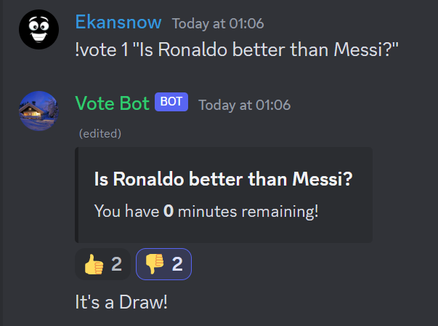

When no options are provided in command then the bot considers Thumbs Up and Thumbs Down as reactions to vote from.

**CASE 2: -**

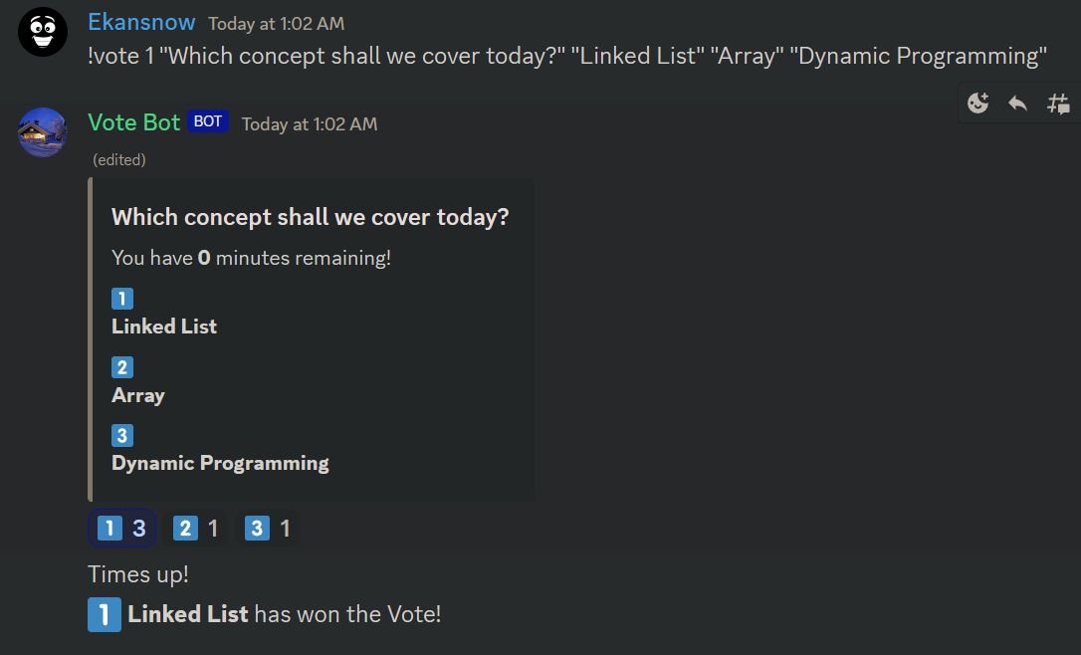

!vote 1 "Which concept shall we cover today?" "Linked List" "Array" "Dynamic Programming"

For this type of command i.e. for commands with options, the bot labels each option as a numerical emoji and sets them at the bottom for the community to vote.

**Highlights: -**

1- If there is a single emoji with maximum votes, then it is sent as a result. Like in below case.

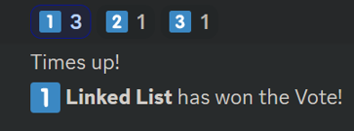

2- There is code snippet within the bot which keeps changing the original embed message with updated minutes. This decrement in time keeps happening until number of minutes go down to 0 and the result is displayed.

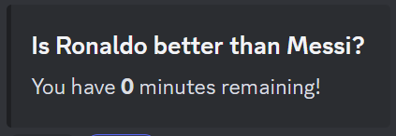

3- If number of options are more than 10 then the command doesn’t execute and return below message.

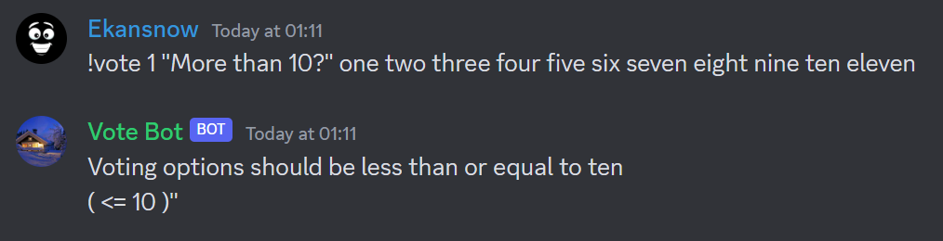

4- It is a common mistake to miss the time(number of minutes) within the command.  
The bot doesn’t execute the command and returns the appropriate format as samples.

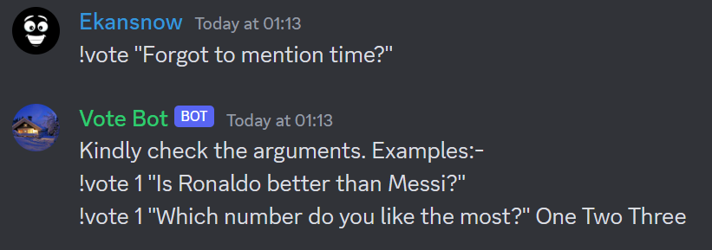

Thank you for going through the document and checking the value this bot can create.